7)Get Help in Red Hat Enterprise Linux (RHEL)
Resolve Problems Using Help Systems and Commands

1. --help Option
Gives quick help and lists available options for a command.
Syntax:
command --help
Example:
mkdir -–help

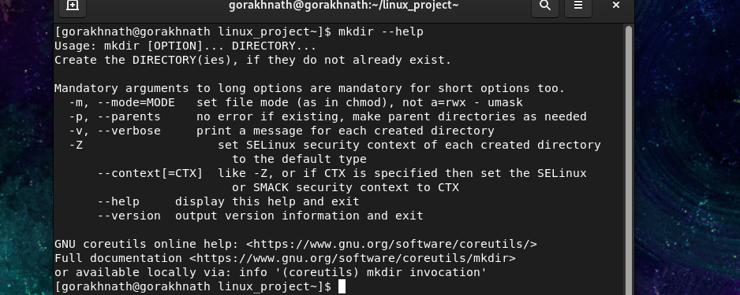

2. man Command
Displays the complete manual of a command.
Syntax:
man command
Example:
mkdir -–help

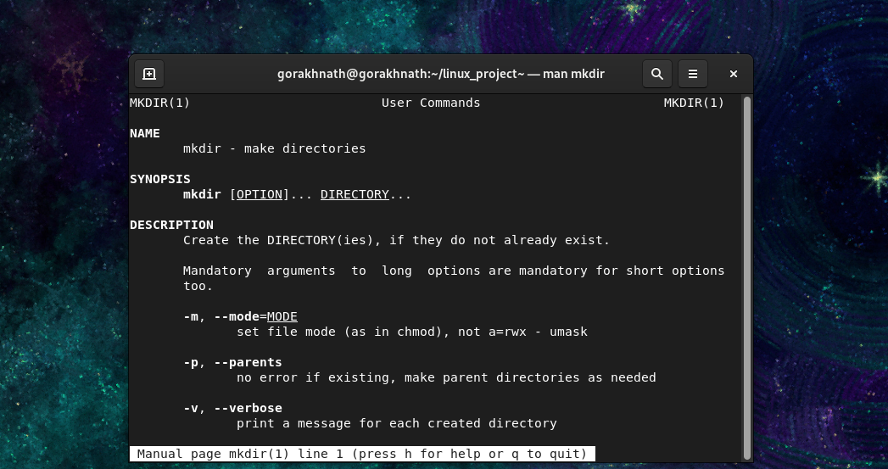

3. which Command
Shows the location of a command.
Syntax:
which command
Example:
which mkdir

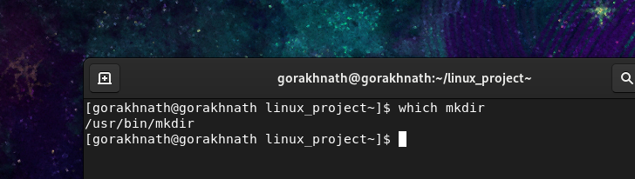

4. find Command
Used to search files and directories in the filesystem.
Syntax:
find [path] [options] [name]

STEP 1: Create a Practice Directory
mkdir ~/find_demo
cd ~/find_demo
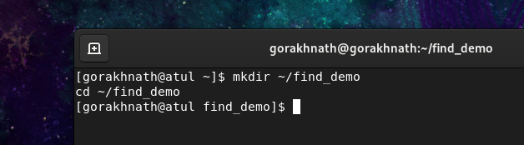

STEP 2: Create Files, Directories & Links
mkdir 1 2 3
touch file1 File2 emptyfile
touch 3/app.log 3/error.log
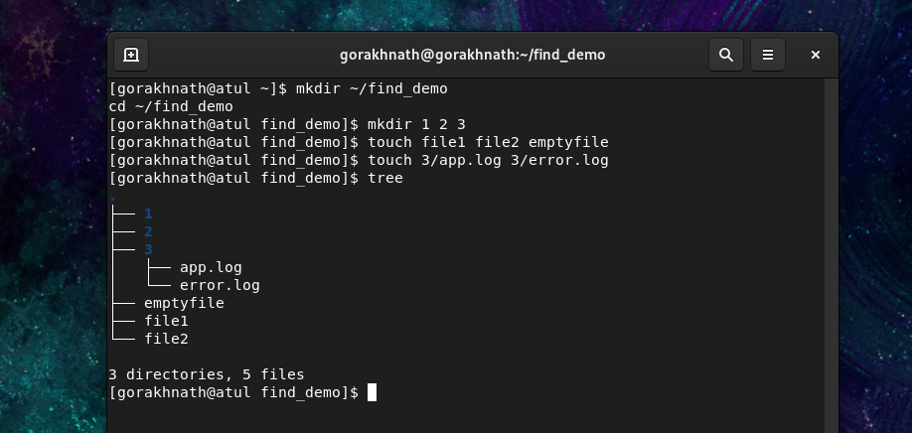

STEP 3: Add Data to Files
echo "Hello" > file1
echo "User: gorakh" > File2
echo "ERROR: Disk full" > 3/error.log
echo "INFO: App started" > 3/app.log

4)FIND COMMAND – Used to find files and directory.

1️.Find file by name
find ~/find_demo -name file.txt
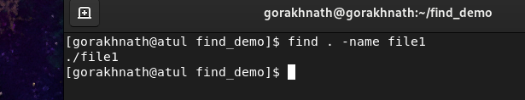

2 .Case-insensitive search
find ~/find_demo -iname file2.txt
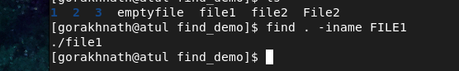

3. Find directories only
find ~/find_demo -type d
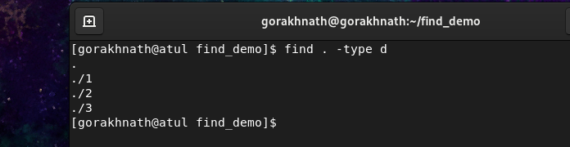

4. Find regular files only
find ~/find_demo -type f
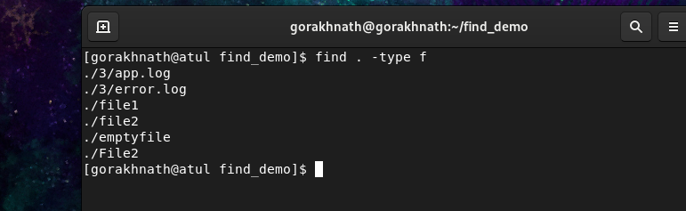

5.Find files larger than 1MB
find ~/find_demo -size +1M


6.Find empty files
find ~/find_demo -type f -empty
Output:
Emptyfile
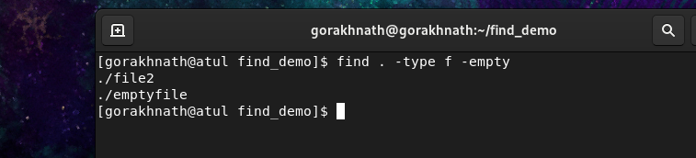

7. Find .log files and delete (⚠ careful)
Preview first:
find ~/find_demo -type f -name "*.log"
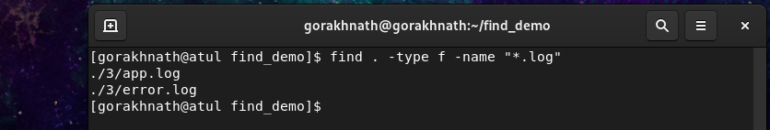
Delete:
find . -type f -name "*.log" –delete

find . -type f -name "*.log" -exec rm -i {} \;
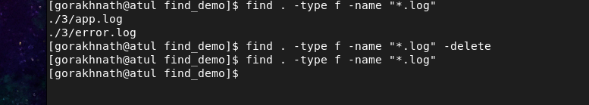

To delete all the files and folder we use below command
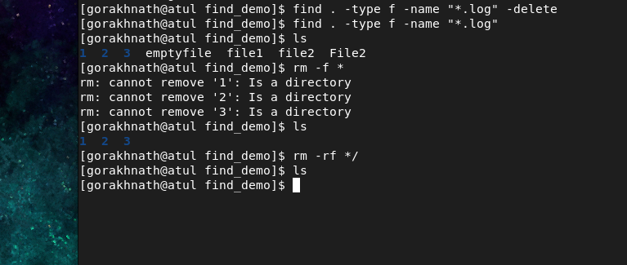
rm -rf * :- to delete all the folders in current directory
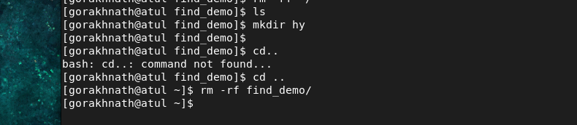

5)grep :- used to find the string.

STEP 1: Create Practice Directory
mkdir ~/grep_demo
cd ~/grep_demo
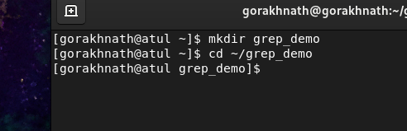

STEP 2: Create Files
touch file1 file2 file3 file4
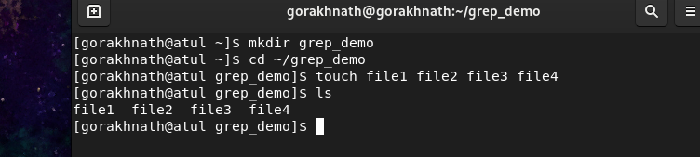

STEP 3: Add Sample Data
echo "INFO: Application started
ERROR: Disk full
Error: Permission denied
DEBUG: Testing mode" > file1
echo "success: login completed
success: file uploaded
debug: variable check
failure: login failed" > file2
echo "user admin login success
user root login fail
user test login fail" > file3
echo "user admin
username admin123
user root" > file4

What each part means
cat
cat normally displays or combines text.

> file4
Redirects output into a file named file4.
- Creates the file if it doesn’t exist
- Overwrites it if it already exists

🔟 grep COMMAND – PRACTICAL DEMO

1️⃣ Search word in a file
grep "ERROR" file1
Output:
ERROR: Disk full


2️⃣ Case-insensitive search
grep -i "error" file1
Output:
ERROR: Disk full
Error: Permission denied
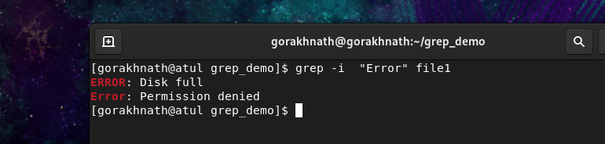

3️⃣ Search in multiple files
grep "login" file2 file3
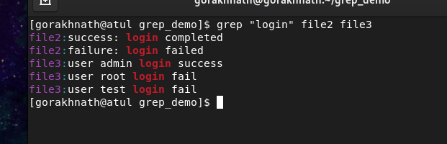

4️⃣ Show line numbers
grep -n "fail" file3
Output:
2:user root login fail
3:user test login fail
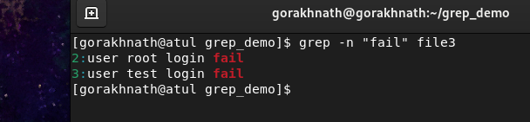

5️⃣ Search recursively in directory
grep -r "user" .
Output:
./auth.log:user admin login success
./auth.log:user root login fail
./file.txt:user admin
./file.txt:user root
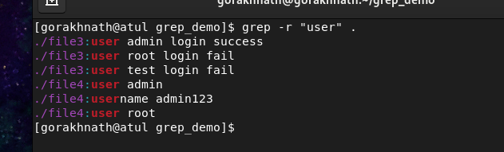

6️⃣ Count matching lines
grep -c "success" file2
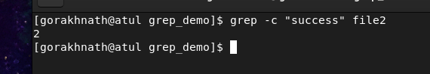

7️⃣ Match whole word
grep -w "user" file4
Output:
user admin
user root
(username is NOT matched ✔)
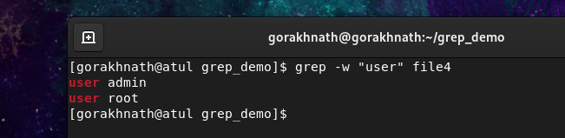

8️⃣ Invert match (not matching)
grep -v “debug” file2

Output:
success: login completed
success: file uploaded
failure: login failed
